1 – How to access to CANVA

2 – How to create account on canva

3 – How to design poster using canva

4 – How to design presentation slide using canva

5 – How to design video using canva

6 – How to design website using canva

7 – How to flyer using canva

8 – How to CV using canva

9 – How to design facebook post using canva

**Project – 1**

**Design your poster**

**Example:**



**Project – 2**

**Design your CV**

**Example: (save it as pdf file)**

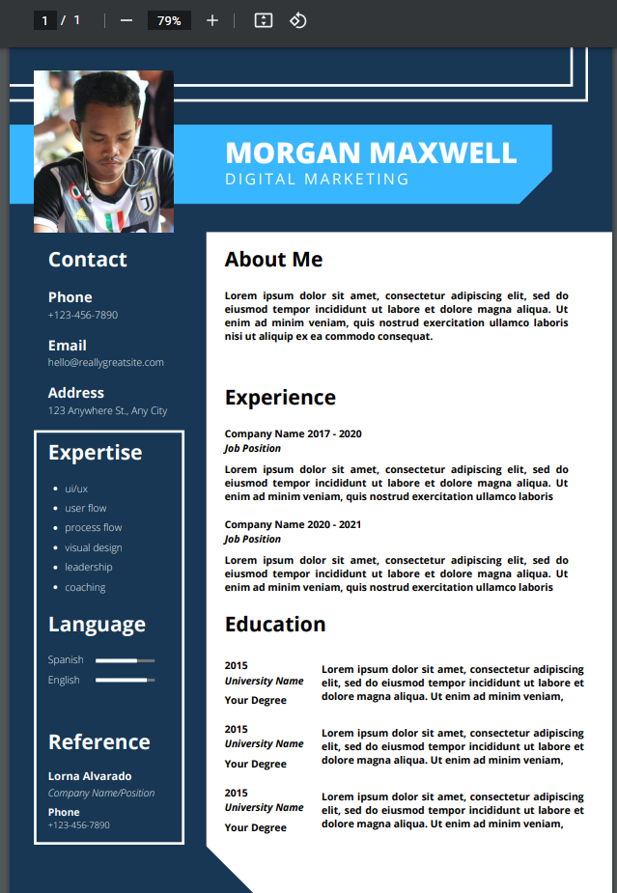

**Project – 3**

**Create presentation slide**

* **5 slides at least**
* **The content of slide about any topic you want to put**

**Project – 4**

**Create video**

* **Create at least 3 minutes videos**
* **About yourself, family, friends …**